Graph Guessing

Using UP2P API develop a math guessing game where you can download a copy of a function a user has made, and make a guess at what the function is.

# Specifications

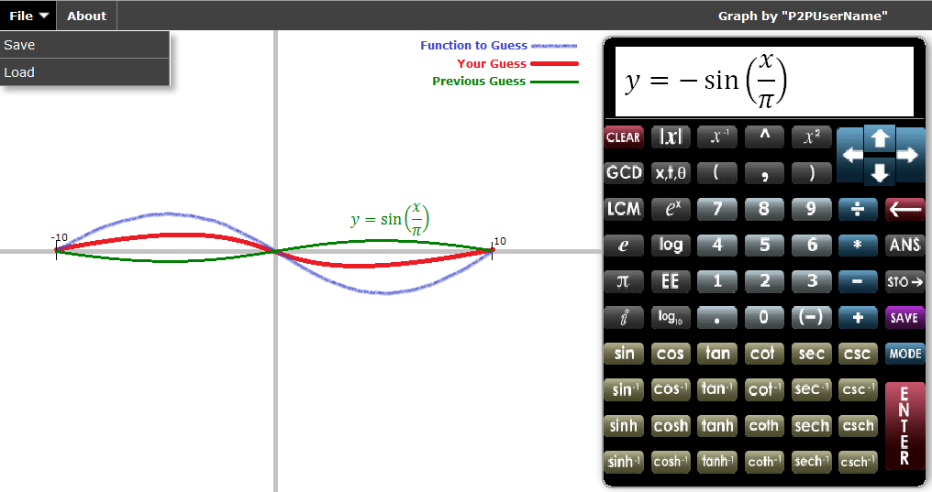

Figure 1: Possible Layout of application

* download graphs and other guesses for a graph from other users
* save a guess made on a graph
* type in equations with the keyboard or with the on screen calculator buttons

# Potential Starting Points

[HTML5 for Publishers](http://www.amazon.com/HTML5-for-Publishers-ebook/dp/B005XE2CAO/ref=sr_1_1?s=books&ie=UTF8&qid=1342556399&sr=1-1&keywords=html5+for+publishers)

Licencing:

Code is generic and irrelevant, licencing and copyright is not important

Pros:

1. Free at time of writing this document
2. Has a tutorial on writing a graphing calculator
3. Contains good of information on starting html5

Cons:

1. The calculator built with the book is very basic and can only graph linear plots as it is
2. Lots of redundant information (as with so many programming books)
3. Googling tutorials often just as helpful if not more so

Recommendation:

Use to help get an understanding of <canvas> and some of the JavaScript behind the calculator. Use one of the already existing calculators as they have more features.

[Graph.tk](http://graph.tk/)

Licencing:

[GPL Free Software Licence](http://www.gnu.org/licenses/gpl.html) (free to use, modify and redistribute provided it is free)

Pros:

1. Open Source (on [Github](https://github.com/aantthony/graph.tk))
2. Supports [MathQuill](http://mathquill.com/)
3. Does integration
4. Supports many variables such as theta and can write as an expression of x
5. API available

Cons:

1. New version in development, old code is going to be discarded, may inhibit what we want after
2. I cannot seem to get it to work locally
3. Complicated file structure
4. API is very basic

Recommendation:

Very powerful and contains the math features which would be nessisary for determining the difference between the two plots. If the program can be understood use this one. There is a very rudimentary API available but it only has the ability to show a graph on another web site.

[Function Plotter](http://www.snappymaria.com/canvas/FunctionPlotter.html)

Licencing:

No mention of any licencing or copyright, The owner of the web site seems to have put the code up solely for their personal interest.

Pros:

1. Open Source (download the page)
2. All in one html file makes for quick understanding

Cons:

1. Does not do any calculations
2. Only supports functions where y=something

Recommendation:

Simple enough to do what we want needs features like the math to determine difference between two plots. If Graph.tk does not work out, use this one.

[FooPlot](http://fooplot.com/)

Licencing:

[GPL Free Software Licence](http://www.gnu.org/licenses/gpl.html) (free to use, modify and redistribute provided it is free)

Pros:

1. Open Source
2. User friendly interface

Cons:

1. Messy Code

Recommendation:

2nd choice behind Graph.tk

[Desmos Calculator](https://www.desmos.com/calculator)

Licencing:

No information on licencing or ways to use/modify the source code, a partnership email address is available at [partnerships@desmos.com](mailto:partnerships@desmos.com) but may be too complicated a process for what we would be using the tool for.

Pros:

1. Very user friendly
2. Supports MathQuill
3. Supports all sorts of equations and variables
4. Has sliders for variables

Cons:

1. Not open source but they are hoping to build an API in the future

Recommendation:

Do not use until API ready; Check back every so often for updates on API progress.

[D3](http://d3js.org/)

Licencing:

Redistribution with modifications or not are allowed, all copyright notices but be maintained

Pros:

1. becoming a well-known graphing utility
2. well documented
3. powerful set of tools to allow for all sorts of graphs and plots
4. available on [GitHub](https://github.com/mbostock/d3)

Cons:

1. many functions which are unlikely to be used
2. no examples on doing basic math plots

Recommendation:

D3 is powerful in ways that are outside of what this project is about, I suggest not using unless already familiar with how D3 works.